**Classroom Activity: Write a code to create class components in ReactJS**

**Code:**

File Name: src/App.js

import React, { Component } from 'react';

class App extends Component {

  render() {

    return (

      <div>

        <h1>Hello, World!</h1>

      </div>

    );

  }

}

export default App;

**OUTPUT:**

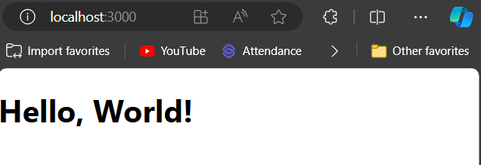

Figure: Output Screenshot

**Execution Steps:**

* Write the above code
* Go to VS Code terminal
* Execute following command to run the program: npm start
* This will open your default browser and navigate to http://localhost:3000, where you will see your new React application running.